|  |
| --- |
|  |
| Device Verification Subsystem 1.0.0  User Guide (Public Mobile App)  DVS-User-Guide-Public-Mobile-App-1.0.0  June 19, 2018 |

|  |
| --- |
|  |

Revision history

|  |  |  |
| --- | --- | --- |
| Revision | Date | Description |
| A |  | Initial release |

|  |
| --- |
|  |

# **Contents**

**1. Introduction 5**

1.1. Purpose 5

1.2. Supported OS Versions 5

1.3. Definitions, Acronyms, and Abbreviations 5

**2. App Description 6**

**3. App Navigation 7**

3.1.Enter the IMEI 7

3.2.Scan Barcode 10

Figures

Figure 1-Check IMEI Status 7

Figure 2-reCAPTCHA 8

Figure 3-Device Status 9

Figure 4-Scan Barcode Icon 10

Figure 5-Allow Button 11

Figure 6-Scan Barcode Window 12

Figure 7-Scanned IMEI 13

Figure 8-reCAPTCHA Window 14

Figure 9-Device Status Table 15

Tables

Table 1-Supported OS Versions 5

Table 2-Definitions, Acronyms, and Abbreviations 5

Table 3-System Descripti*o*n 6

# **Introduction**

Device Verification Subsystem DVS mobile app is based on the subsystem of Device Identification, Registration and Blocking System (DIRBS). It provides platform for Device Dealer(s) and, Mobile User(s) to check the status of IMEIs.

The Device Identification, Registration & Blocking System (DIRBS) is a country-wide system deployed in cooperation between the country regulator, operators in that country, and a technology partner that supports deployment. The system checks, identifies, and discourages non-compliant devices by verifying the installed base of devices currently active in a market and continuing to monitor as new devices are activated.

DIRBS can verify that:

* Devices have properly allocated identifiers and type approval
* Devices are not duplicated or stolen
* Device importation takes place through legal channels

## **Purpose**

This document is intended to give assistance to the user to use the DVS mobile app.

## **Supported OS Versions**

Table 1-Supported OS Versions

|  |  |
| --- | --- |
| Name | Version |
| Android | 4.1 |
| iOS | 9.0 |

## **Definitions, Acronyms, and Abbreviations**

Table -Definitions, Acronyms, and Abbreviations

|  |  |
| --- | --- |
| ****Term**** | ****Definition**** |
| **DIRBS** | **Device Identification Registration and Blocking System** |
| **IAM** | **Identity Access Management** |
| DVS | Device Verification Subsystem |
| MSISDN | Mobile Subscriber Integrated Services Directory Number |
| IMEI | International Mobile Equipment Identity |

# **App Description**

Table -System Descripti*o*n

|  |  |
| --- | --- |
| Feature | ****Description**** |
| Enter the IMEI | Takes the valid IMEI as input. Enter IMEI of device to be verified |
| reCaptcha | reCaptcha is used in order to protect the system from the bots(-bot-is a software application that runs automated tasks (scripts ) over the internet ) |
| Scan Barcode | Allows user to scan the barcode of the device |
| Device Status | Display the relevant device details (IMEI, Brand, Model Name, IMEI Compliant Status etc.) in a table |

# **App Navigation**

# **Enter the IMEI**

1. Enter the IMEI in the respective field

**Note**: IMEI can contain alphanumeric characters (0-9, A-F, a-f). The length of the IMEI should be between 14-16 characters.

1. Tap on the “Submit” button

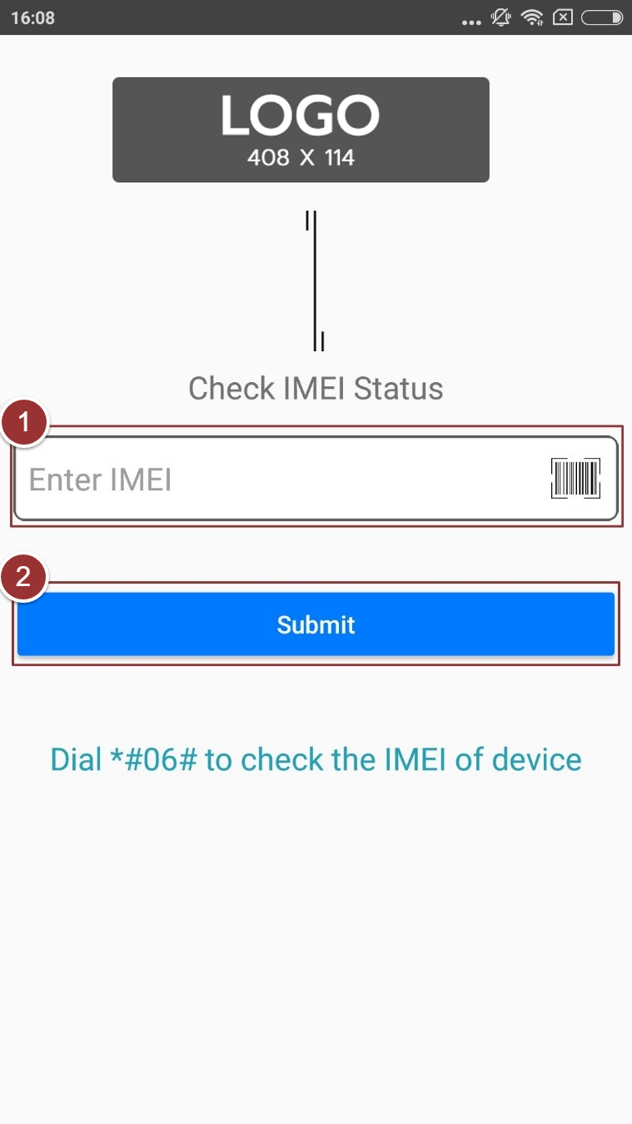

Figure 1-Check IMEI Status

After tapping on the “Submit” button, reCAPTCHA window will popup, complete the verification process.

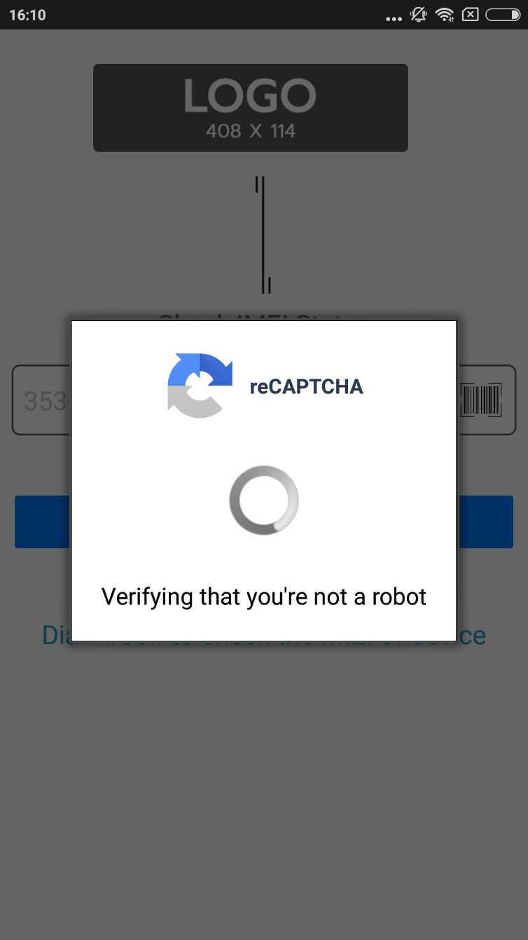

Figure 2-reCAPTCHA

Status of the device will display in a table with details (i.e. IMEI, Brand, Model Name, IMEI Compliance Status etc.)

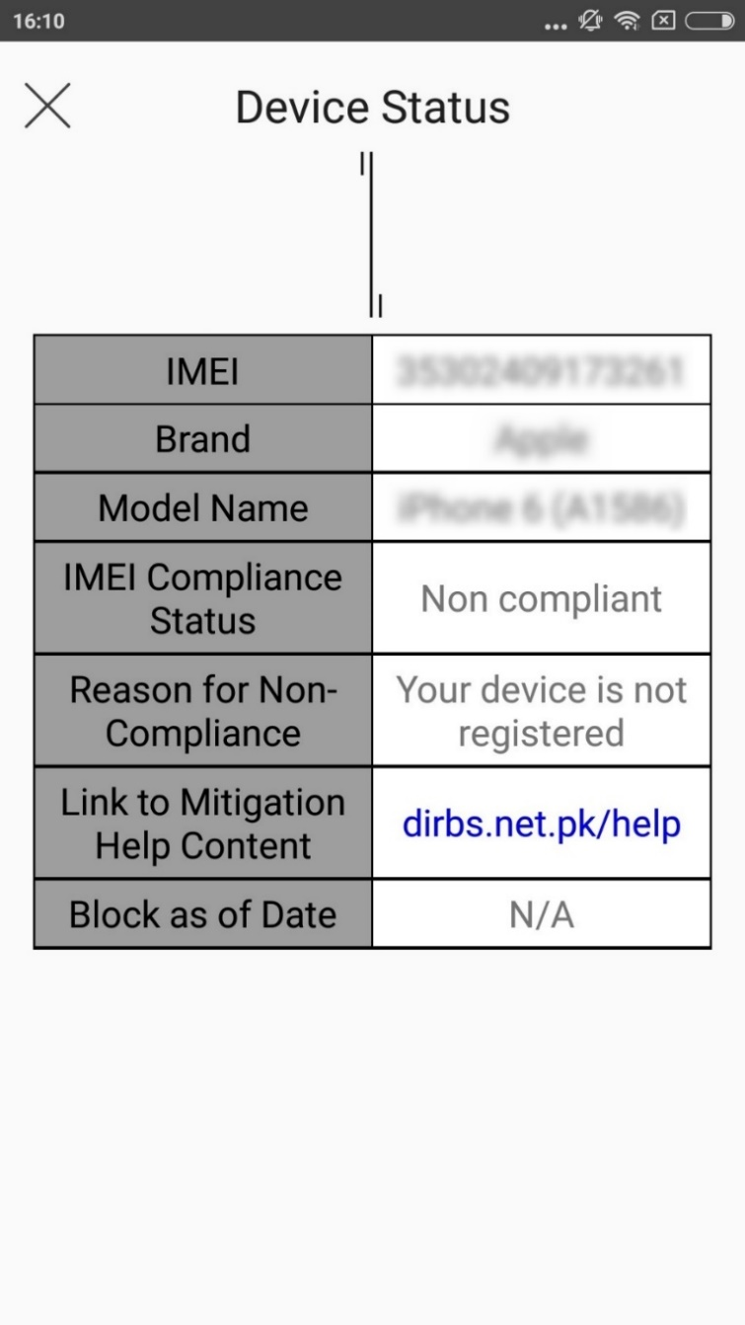

Figure 3-Device Status

# **Scan Barcode**

1. To scan the barcode, tap on the “Scan Barcode” icon

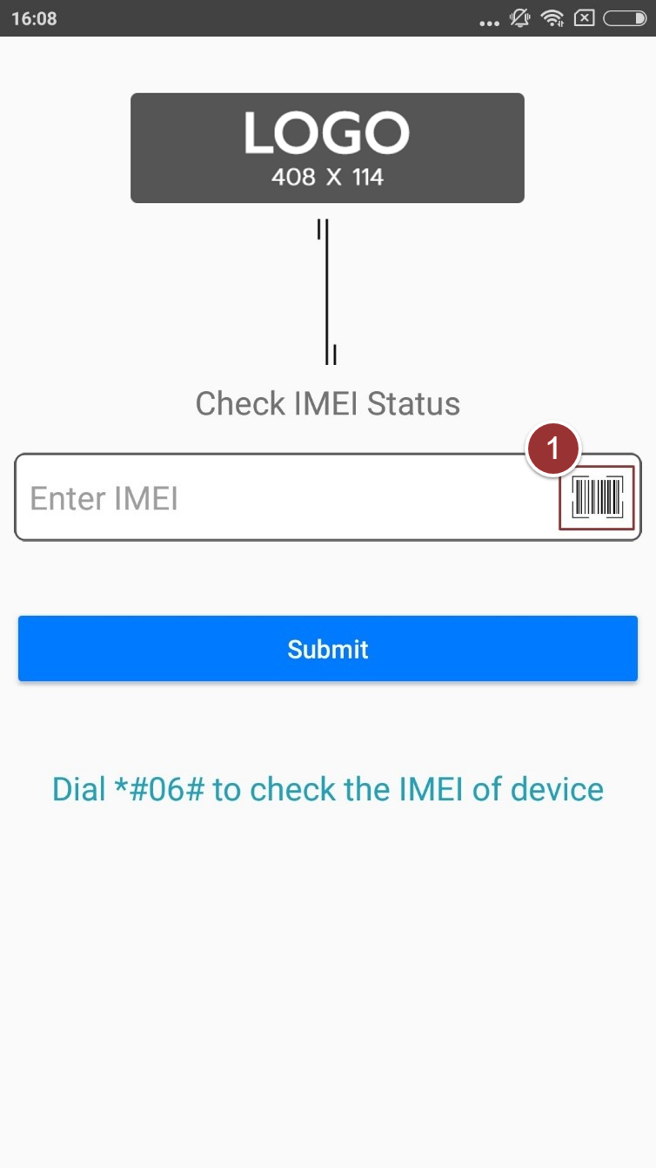

Figure 4-Scan Barcode Icon

1. Allow the app to access device’s camera

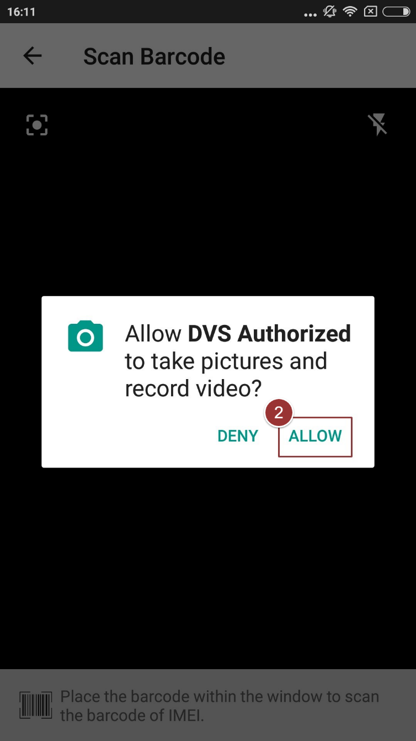

Figure 5-Allow Button

1. Place the barcode within the window to scan the barcode of the IMEI

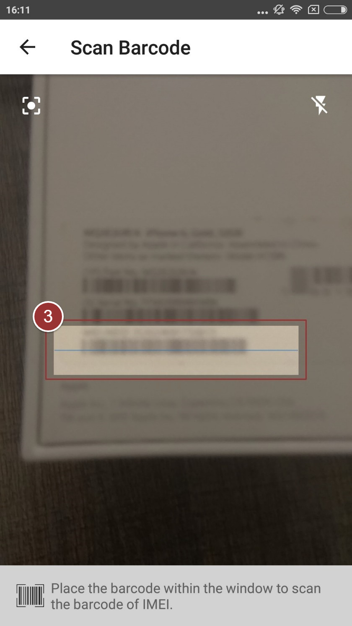

Figure 6-Scan Barcode Window

1. Click on the “Submit” button

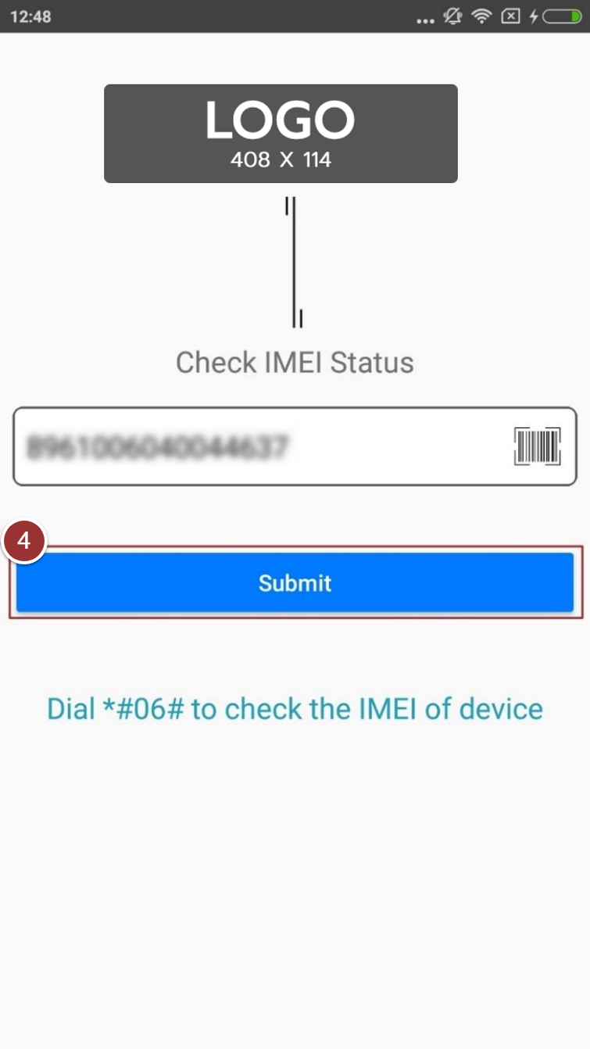

Figure 7-Scanned IMEI

After clicking on the “Submit” button, reCAPTCHA window will popup, complete the verification process.



Figure 8-reCAPTCHA Window

Status of the device will display in a table with details (i.e. IMEI, Brand, Model Name, IMEI Compliance Status etc.)

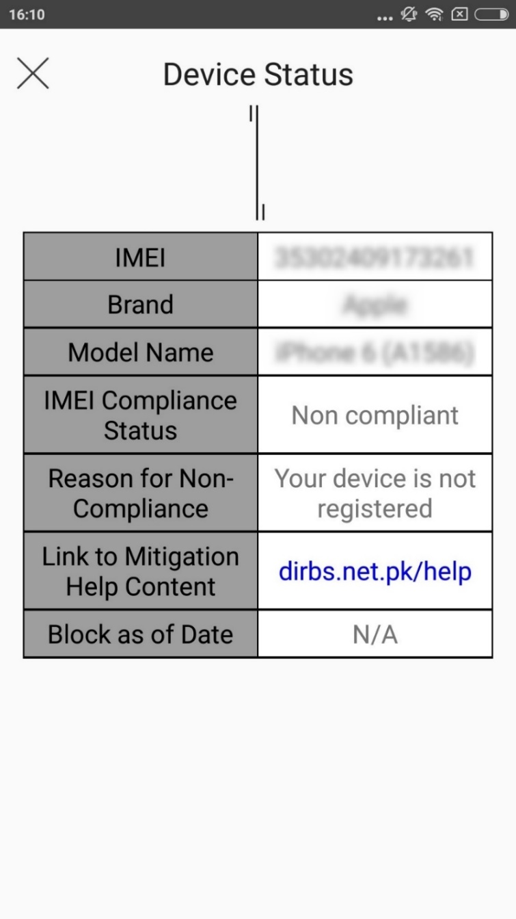

Figure 9-Device Status Table